**GIT SETUP**

1) Download and install Git

<https://git-scm.com/downloads>

2) Create folder in any drive eg: D:\HackthonApps

3) Open git bash

I) For Angular

a) Go to the respective folder by typing following command

cd D:\HackthonApps

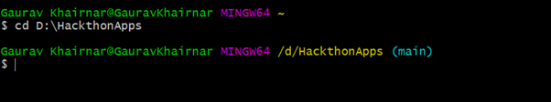

b) Create clone of it

Execute command:

git clone <https://github.com/gauravkhrnr21/HackathonDemoApp.git>

II) For Nodejs :

a) Go to the respective folder by typing following command

cd D:\HackathonApps

b) create clone

Execute command:

git clone https://github.com/gauravkhrnr21/HackathonNodeApp.git

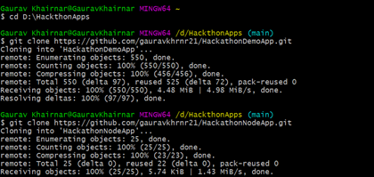

**Download & Install Node**

1) <https://nodejs.org/en/download/>

2) Check the version

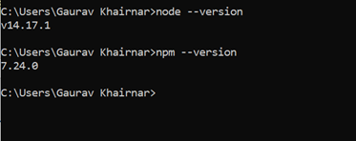

**Install Angular CLI:**

Run “npm I @angular/cli” command on cmd

Please check https://www.npmjs.com/package/@angular/cli

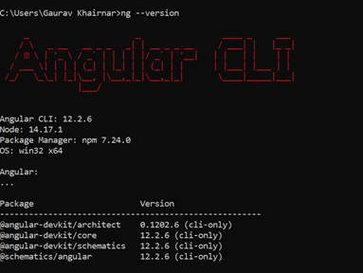

**NodeJS Setup:**

1) Create new DB (hackathondb) & change DB credential in db.config.js

2) Insert records in roles table which is auto generated by the code

INSERT INTO roles VALUES (1, 'user', now(), now());

INSERT INTO roles VALUES (2, 'moderator', now(), now());

INSERT INTO roles VALUES (3, 'admin', now(), now());

3) Check records properly inserted or not

Select * from roles;

4) Add chrome postman plugin if it’s not there [**https://chrome.google.com/webstore/detail/postman/fhbjgbiflinjbdggehcddcbncdddomop?hl=en**](https://chrome.google.com/webstore/detail/postman/fhbjgbiflinjbdggehcddcbncdddomop?hl=en)

5) Go to the postman in chromes app (skip step 4 if plugin already added)

6) Add API uri & change the request type as post

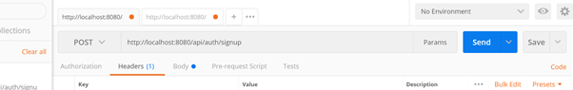

7) Add content type key in request headers as follows

key: content-type , value: applicaion/json

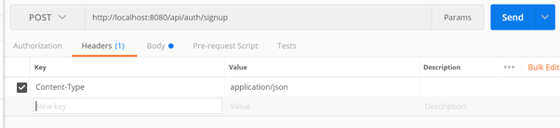

8) In request body add

{

"username":"gaurav",

"email":"gauravkh@gmail.com",

"password":"12345",

"roles":["admin"]

}

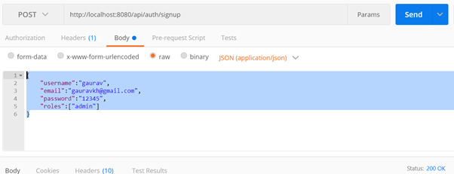

9) Click on send button and check response body

10) RUN

1) Go to the angular project root directory & open cmd

2) In cmd run “npm install” command

3) run “node server.js”

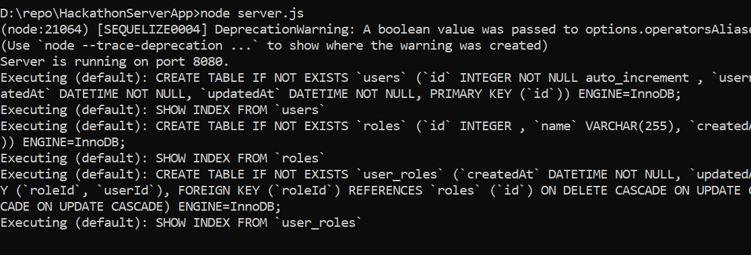

**11) Create model** : Go to the project root dir and run below command then it will create model folder

sequelize -auto -h localhost -d (databasename) -u (username) -x (password) --dialect mysql -t (db names)

E.g sequelize -auto -h localhost -d hackathondb -u root -x root --dialect mysql -t users roles

**Angular Setup:**

1) RUN

I) Go to the angular project root directory & open cmd

II) In cmd run “npm install -d” command

III) run “npm start”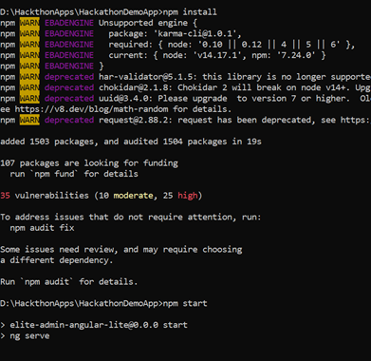

**After login you will see token is stored in session storage:**

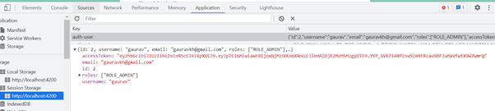

**Screen Shots:**

1. Login Page

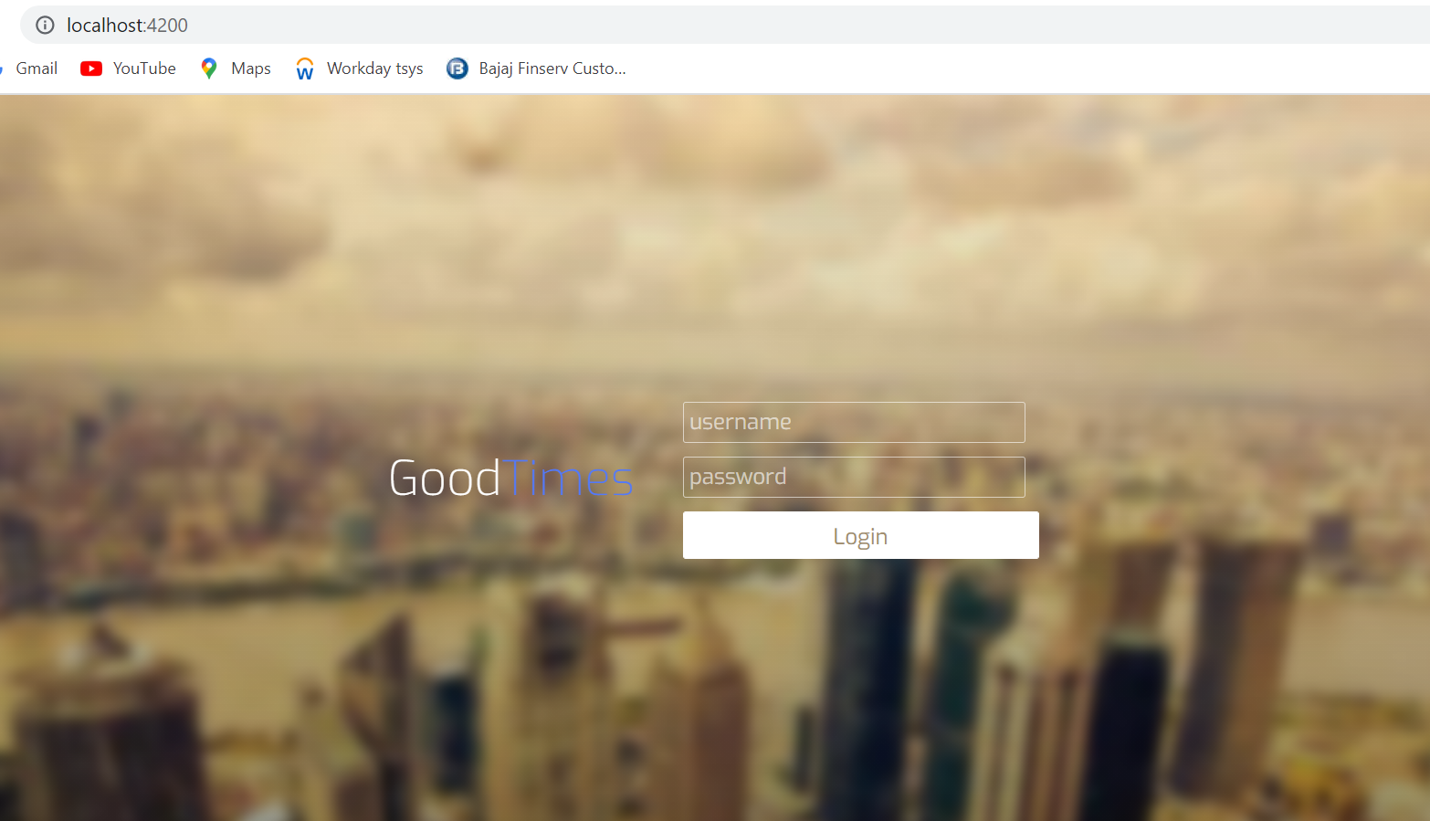

1. Interest Submit Page

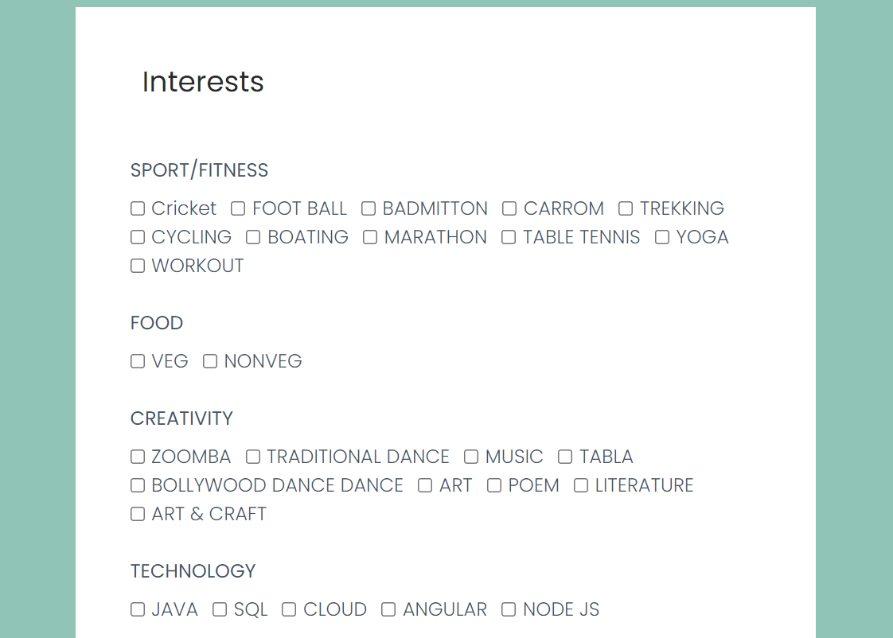

1. Home page

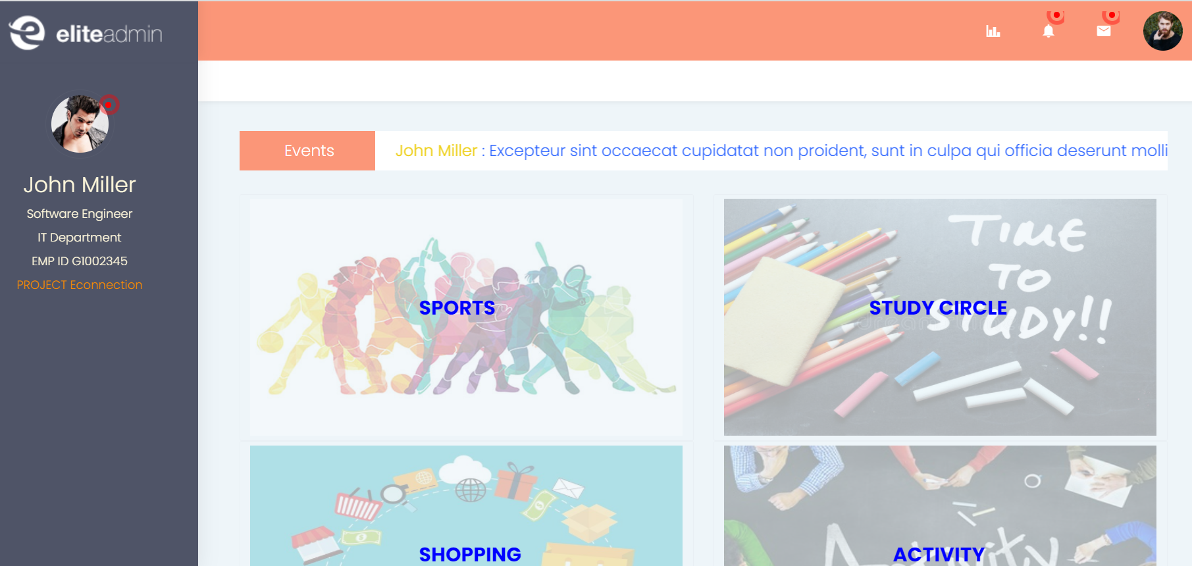

1. Dashboard

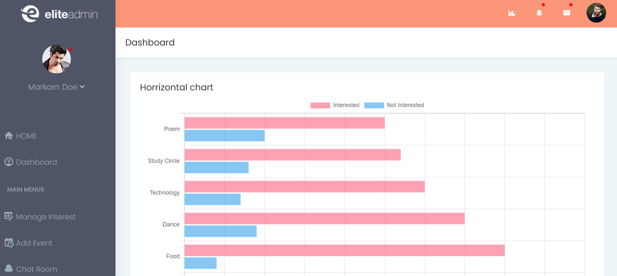

1. Edit Interest

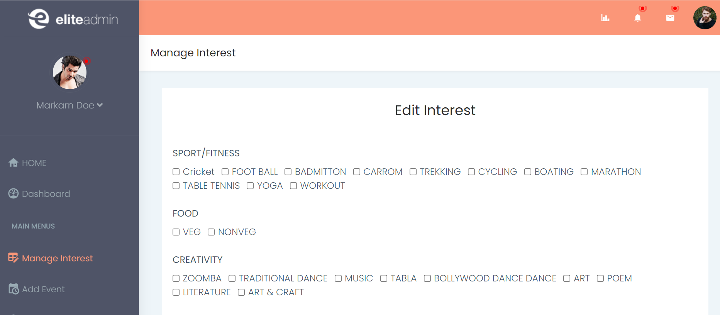

1. Search Interest

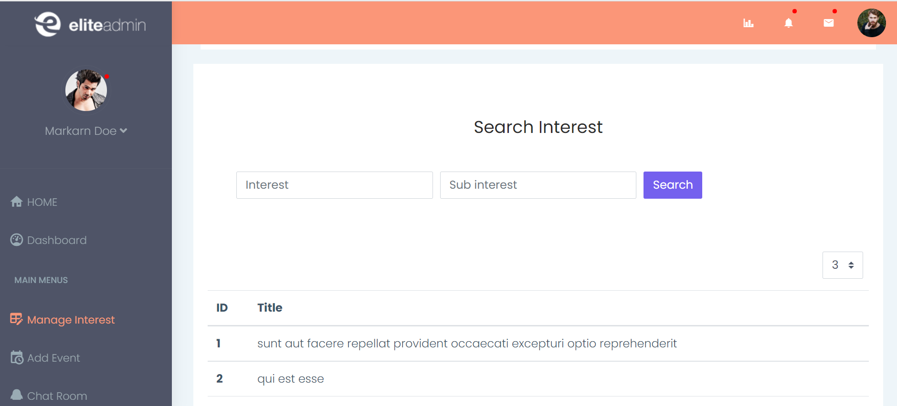

1. Add Event

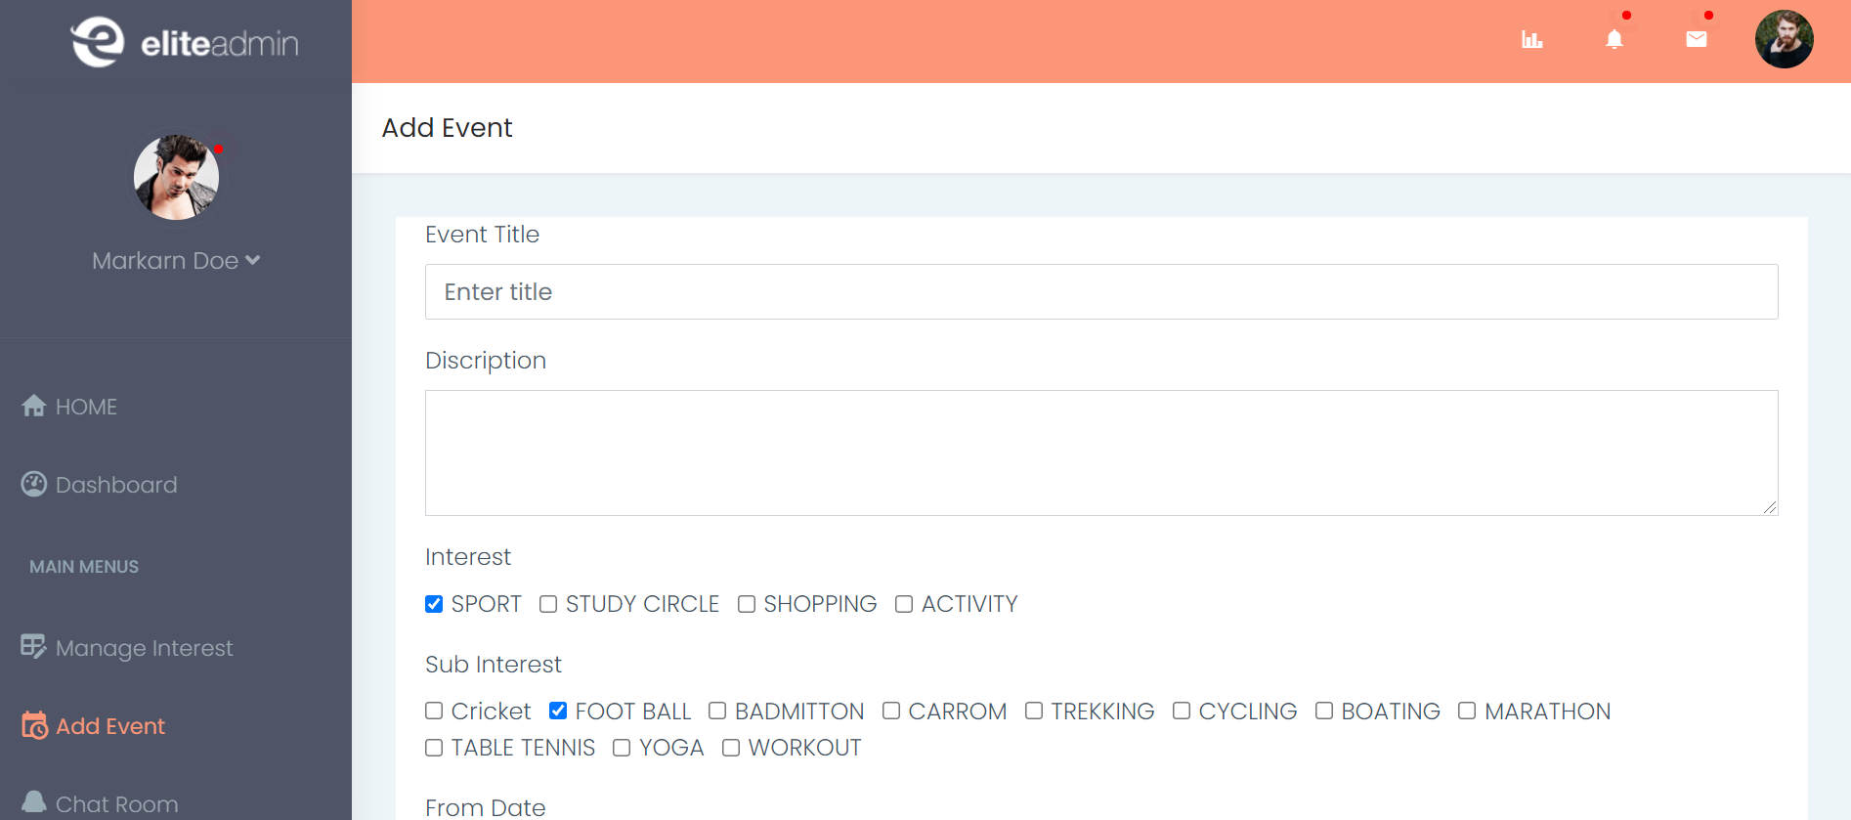

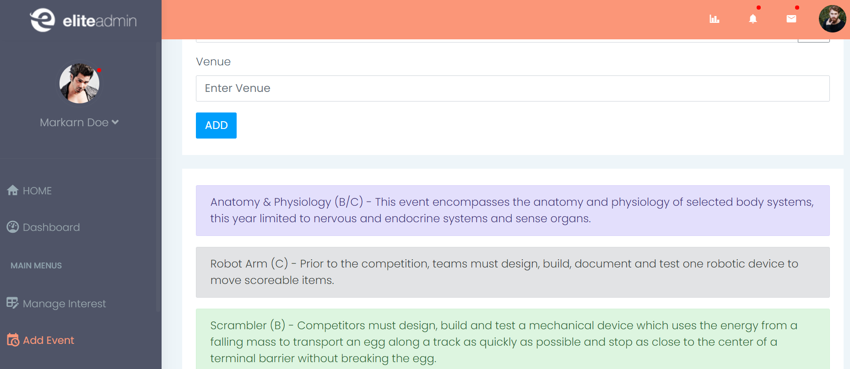

1. Chat Room

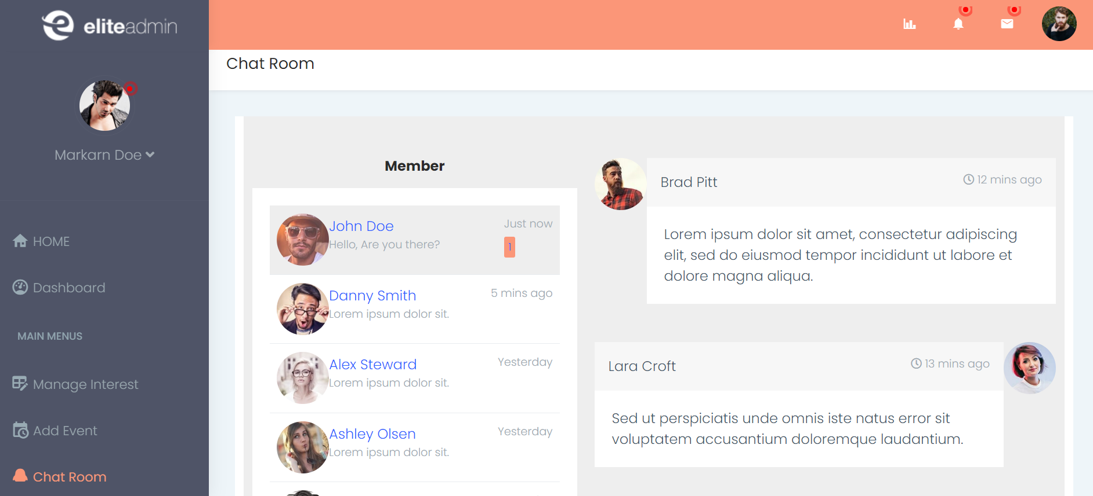

10) Main Interest chart

